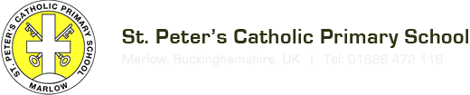

St Peter’s Catholic Primary School
Microsoft Teams Guide for Parents

What does it do? Why use it?
- Teachers can use it to set tasks
- Students can get feedback on tasks
- Teachers can store any type of files so that pupils can access for homework
- WEBSITES which are frequently used can be uploaded, so that pupils have instant access
- Greater equity for our pupils – free access to all Microsoft educational software (PowerPoint, Excel, Sway, Forms, Word etc.)
- Pupils can discuss classwork / collaborate on class projects
- It will encourage our pupils to be more digitally literate – “future proofing”. Many places of work, colleges and universities are working with Microsoft Teams or similar products

The following pages give you a QUICK guide through the basics.

Step1: Log in to Office 365:

Student email accounts are all lowercase and are the first initial (or two if your child has a double barreled first name) followed by their full surname @stpetersrc.bucks.sch.uk.

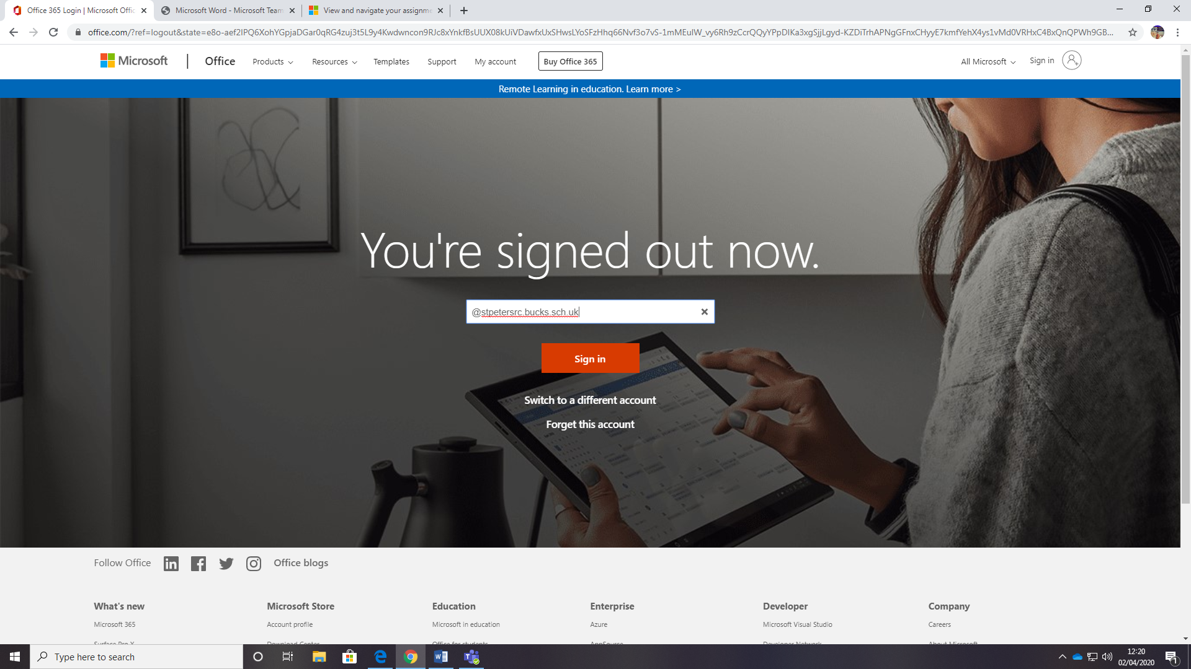

When you have logged into your email account you will see an invitation to join your class Team.

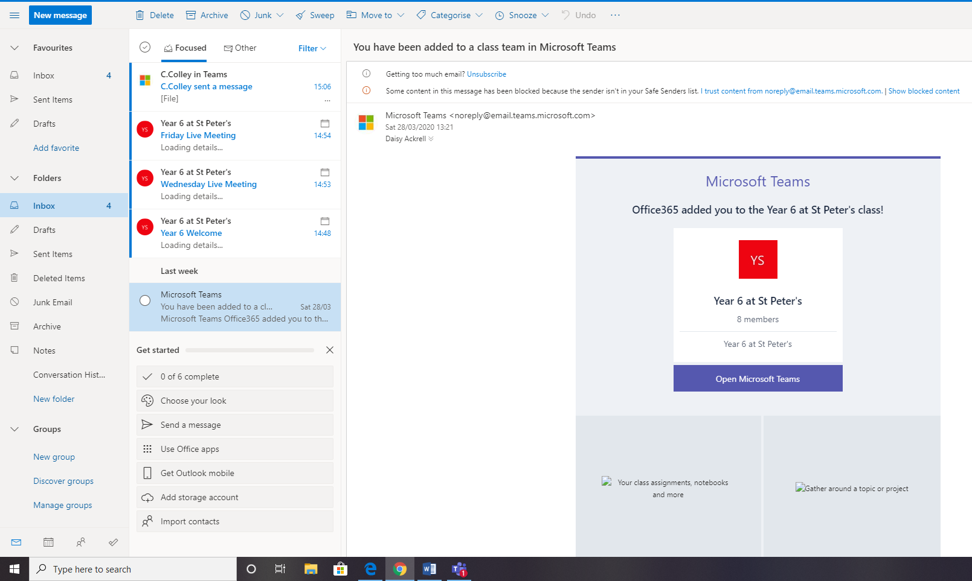

Then you will need to log in again.

Step 2 – Using TEAMS
Home Screen

When you click on your Teams icon, you will see a page like this.
Click on the Teams Icon on the extreme left and you should see your Year group on the left hand side.

You have several tabs running across the top of each class:
Posts, Files, Class Notebook, Assignments, Grades and a ‘+’ sign.

Posts

This tab allows everyone in the Class Team to chat. You can upload files, pictures, documents into your chat.
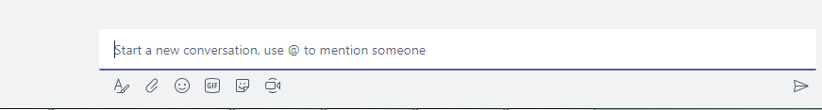
Write your message where it says, “start a new conversation” and click on the send icon to send. Staff can block pupils from this if it becomes inappropriate.

Files

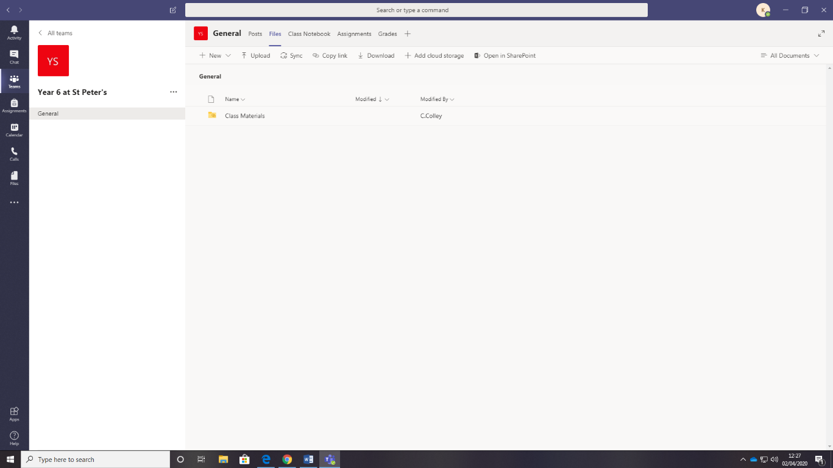
If you click on the Files tab at the top of your class page (beside Posts), you can see any files the teacher has uploaded. However, your teachers will be using the ‘content library’ in class notebook to share resources and tasks. Do not upload your own work to ‘Files’, as it is public. You have your own upload folder, which can only be viewed by your teacher.

Class Notebook

Your tasks will be set here. If you click on the arrow, you can find your folders and work for each day in the dated folders. There will also be some rules for using Teams.

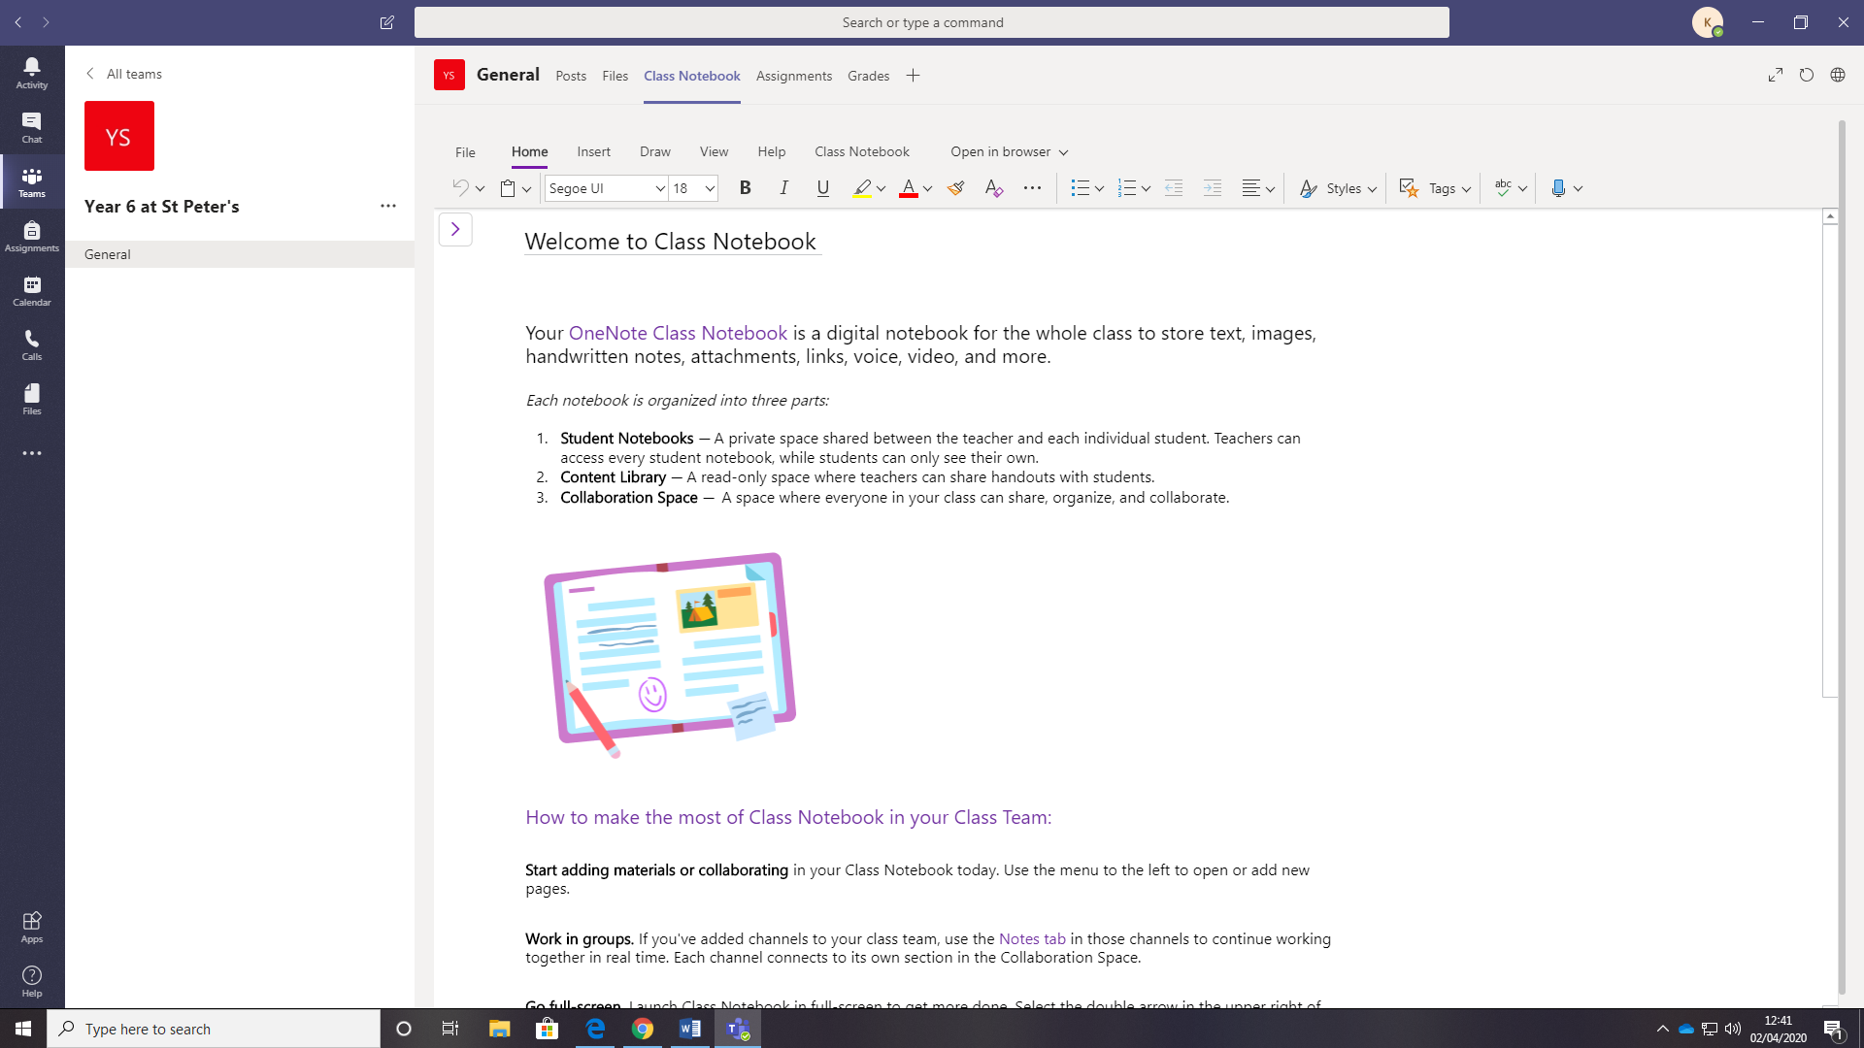

Once you have clicked on the arrow, you will be able to see your folders plus one with your name.

Assignments
This is where tasks can be set.

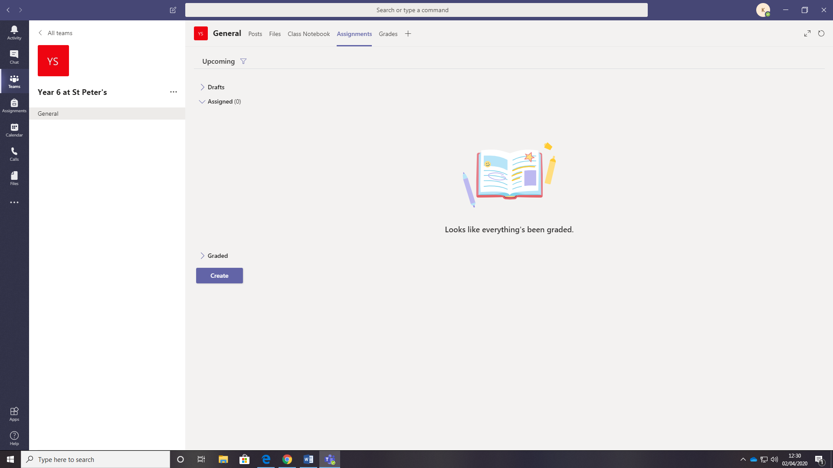

The ‘+’ sign
This is a very useful tab. Teachers can use it to add quick access to websites that are frequently used with classes.
Staff can also add PowerPoints and other files that are frequently used.

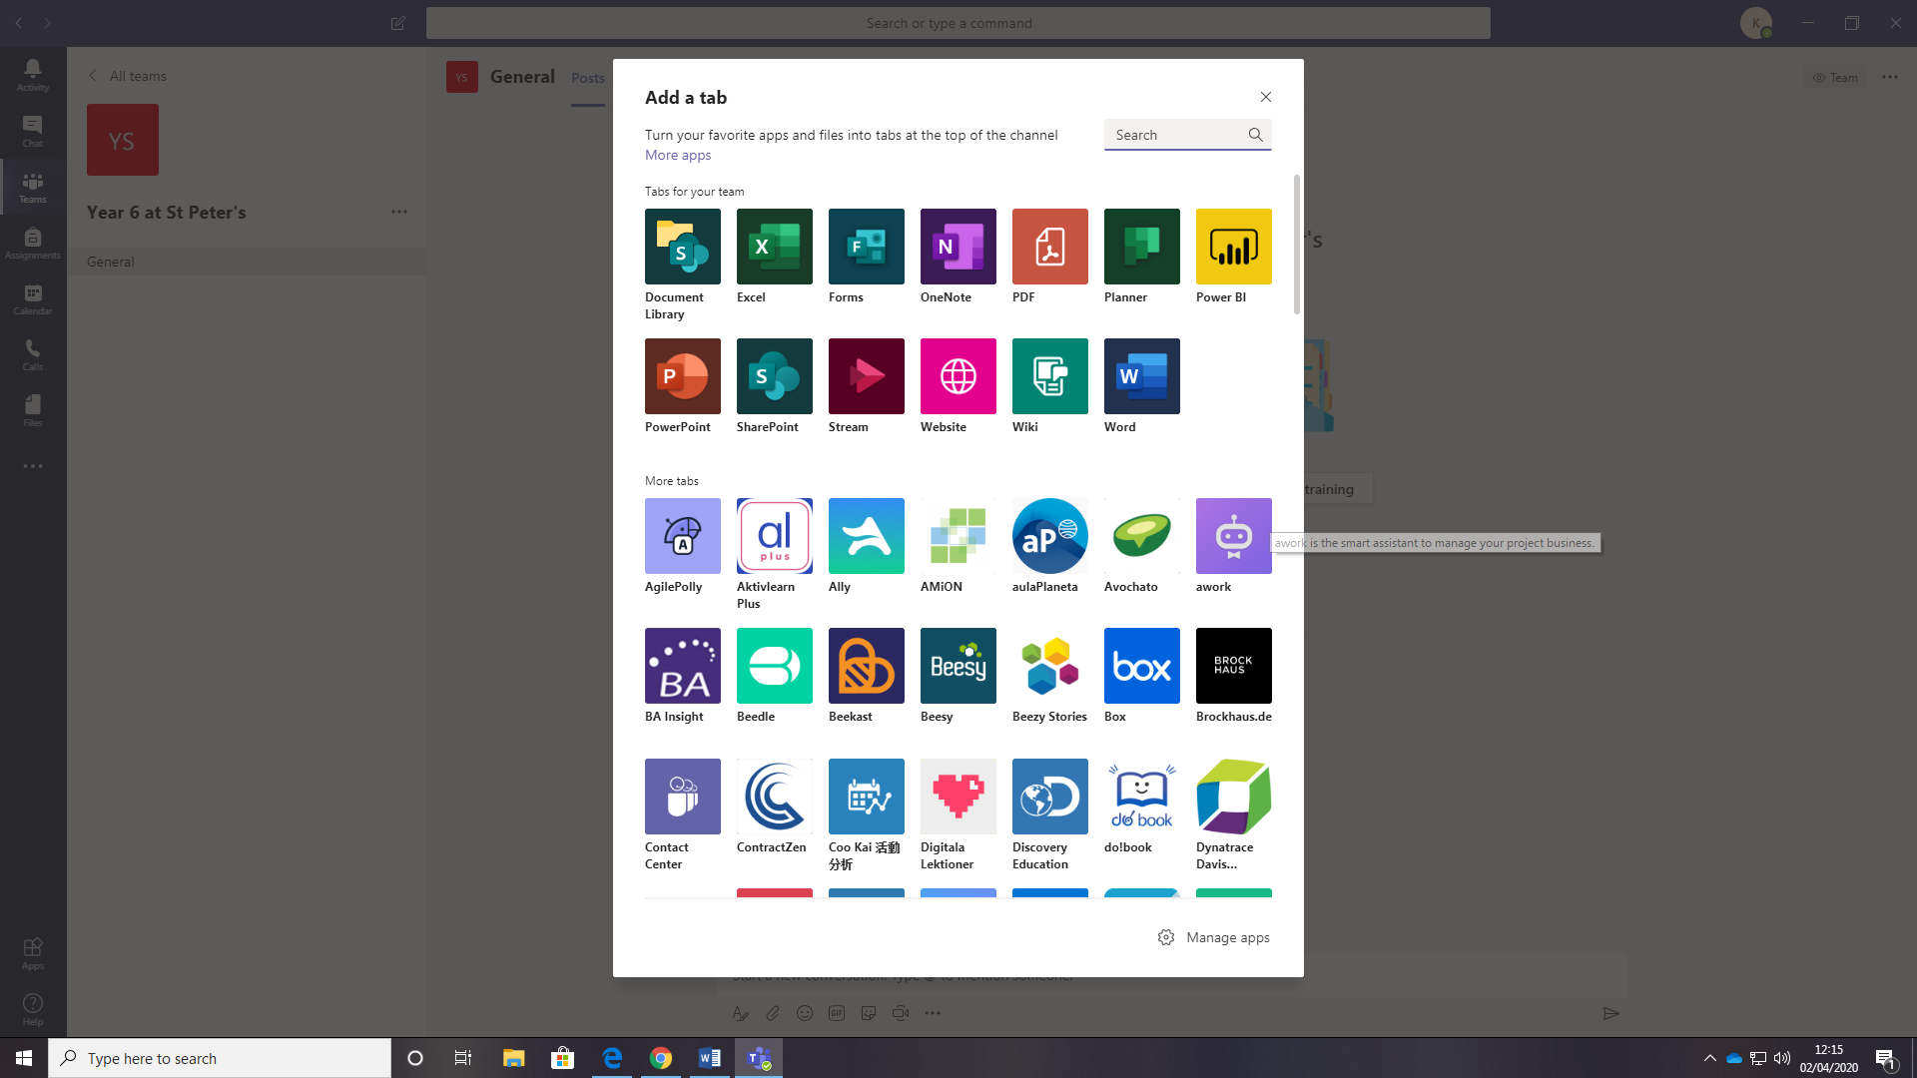

Phones/ Mobile devices
There is a free app for Teams that you can download to access.

