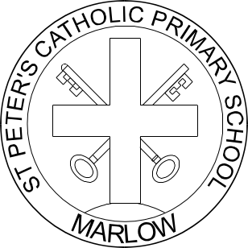

DIOCESE OF NORTHAMPTON
ST PETER’S CATHOLIC PRIMARY SCHOOL
PROSPECT ROAD, MARLOW, BUCKS, SL7 2PJ
Telephone: 01628 472116/7
e-mail: office@stpetersrc.bucks.sch.uk
Web: www.stpetersschoolmarlow.org.uk
Headteacher: Miss A McCluskey, B.Ed.
BUCKINGHAMSHIRE COUNTY COUNCIL – EDUCATION DEPT.

18 September 2020

Dear Parents

Years 4 5 & 6 Football Club

St Peter’s Football Club will start on Thursday 24 September 2020 from 3.30 –
4.30 pm.

Mr Wharton has volunteered to coach the team again this year.

If you would like your child to take part, please complete the slip below and return it to the school office for my attention.

Yours sincerely

Miss A McCluskey
Headteacher

……………………………………………………………………………………………………..

To: St Peter’s Catholic Primary School, Marlow

Name of Child……………………………………………………………………………………

I agree to my child taking part in the after school Football Club with effect from Thursday 24 September 2020.

Signed……………………………………………………………………………………………..
(Parent/Guardian)





