
St Peter’s Catholic Primary School
Year 5 – Autumn 2019

English  Narrative writing based on Greek Myths.  Poetry: use film clips to capture a moment in the life of an Ancient Greek, using Haiku and Tanka. Also, free verse and Kennings to show the life of an Ancient Greek person. Reading a range of texts to clarify meaning, summarise, generate questions and read and retrieve information. | RE  Within the theme of ‘Domestic Church’ we will be exploring the topic of family and ourselves.  Within the theme of ‘Confirmation/Baptism’ we will be exploring the topic of belonging and life choices. | Maths  Consolidation of topics.  Number: place value, addition and subtraction.  Statistics.
Science  Investigating different Forces and their effects. | Ancient Greece  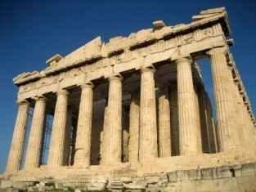 | Computing  Coding and making games on Scratch.  Make an Ancient Greek report for television.
History/Geography  When did the Ancient Greeks live? How does Ancient Greek society influence and shape our lives today? Compare and contrast the lives of athletes, politicians, authors, children and families. Greece: the center of the world? True or false? Alexander the Great – the greatest Empire? Compare and contrast the nations included in the Ancient and modern Olympic Games. Poseidon or Athena: How did the physical landscapes influence the Ancient Greeks? |  | Art/DT  Ancient Greek mosaics.  Drawing Ancient Greek pot.  Pattern work and motifs.
PE  Handball  Gymnastics | Music  Composition.  Listening to Ancient Greek music. | French  Classroom objects/instructions.

English  Newspaper reports – moon landing.  Non-chronological report – space.  Reading a range of texts to infer and deduce and make predictions. | RE  Within the theme of ‘Advent’ we will be exploring the topic of loving and hope.  Within the theme of ‘Local Church’ we will be exploring the topic of community and mission. |  | Maths  Number: multiplication and division.  Measurement: perimeter and area.  Consolidation of topics.
Science  Earth and Space. Finding out about our Solar System. |  | 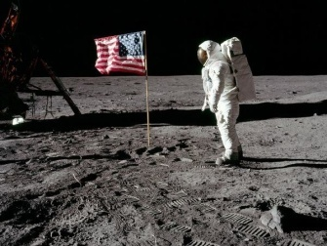  Journey Through Space | Computing  Make hoax UFO pictures.  Coding alien games using Scratch.
History/Geography  Discovering how and where and when the telescope was invented and how they work.  Finding out about the Space Race between the USSR and USA and space exploration between 1940 and 1970.  Exploring the details of the Apollo 11 mission of 1969, the moon landing and who was involved.  Examining methods of space exploration used today. |  |  | Art/DT  Who built the first space ships? Could you design a better one? Can you design and build your own jet-pack or space shuttle?  Creating a fictional planet using mixed media.  Exploring the world of origami and using this understanding to make an origami star.
PE  Hockey  Dance | Music  Creating space music – tuned an.  Christmas music. |  | French  Fruits, days of the week, numbers 13-20.

