St Peter’s Catholic Primary School
Year 3 – Autumn 2020

English  Tales of Gods and Pharaohs: Exploring Egyptian myths and story structure.  Information Texts: Reading and creating information texts.  Shape Poems &Calligrams  Grammar: Nouns, pronouns, adjectives, onomatopoeia, rhyme, question marks & exclamation marks headings & subheadings. |  | RE  Homes: We will be exploring the joys and sorrows of families and how we can learn from God’s example.  Promises: We will be learning about the sacrament of Baptism and the promises that are made at this time. |  | Mathematics  Number: Place Value: Representing numbers to 100& 1000, tens and ones using addition, hundreds, 100s, 10s, 1s, number line to 1000, finding 1,10,100 more or less, comparing numbers and objects to 1000, ordering numbers, counting in 50s.  Number: Addition and Subtraction: Add and subtract a 2digit and 3digit number, crossing 10 or 100, adding and subtracting 3digit numbers, exchanging
Science  Preservation: Keeping food and bodies fresh!  Forces: How do forces make things move? What can magnets do? |  | 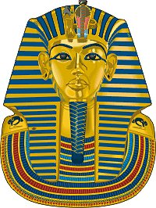  Ancient Egypt |  | Computing  E-safety: Searching the internet safely using child-friendly search engines. Keeping personal data private.  Multimedia: Creating e-books.
History/Geography  Exploring the wonders of Ancient Egypt: pyramids, pharaohs, mummification, hieroglyphics…!  Geographical features of Egypt. |  |  |  | Art/DT  Exploring techniques for capturing portraits, creating Egyptian-style self portraits.  Egyptian themed art & DT.
PE  Netball: Invasion Games  Gymnastics: travelling, climbing and pathways. | Music  Musical contrasts – high and low, fast and slow, loud and soft, one line or two. |  | French  The culture of France, French greetings, and numbers. |  | PSHE  Settling in: Settling back into school, establishing expectations of KS2.  Growth Mindset: Learning about how we think and learn.

English  The Lego Movie: Sets, props and character descriptions.  Instructions: Writing and interpreting instructional texts.  Hans Christian Anderson stories-The Snow Queen  Grammar: Verbs, expanding sentences, prepositions, imperative bossy verbs, causal conjunctions, commas |  | RE  Judaism: We will be learning about the synagogue as the holy place of worship.  Visitors: We will be exploring the joys and demands of visitors and learning about waiting for the coming of Jesus during Advent. |  | Mathematics  Number: Addition and Subtraction: Estimating answers to calculations, checking answers  Number: Multiplication and Division: Using arrays, 2&5 times-tables, grouping and sharing - making equal groups, dividing by 2,5&10, 3,4&8 times-tables, multiplying and dividing by 3, 4 & 8
Science  Amazing Bodies: What do we need to survive and stay healthy?  Can you see me? What do we need to see things? What can mirrors do? |  | 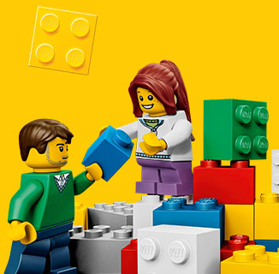  LEGO! |  | Computing  Programming:  Programming a sprite to respond to commands and complete tasks.
History/Geography  The history of Lego and other great designs that have transformed the world!  The geography of Denmark as another European country. |  |  |  | Art/DT  George Seurat – pointillism and art with pixels.  Lego art
PE  Hockey: Bat and Ball skills.  Circuits and Fitness: agility, balance and co- ordination. | Music  Preparing with the school for the Christmas Nativity performance. |  | French  Months, Days of the Week and colours. |  | PSHE  Feelings: We will be learning about the importance of recognizing feelings and their impact on ourselves and others.

