St Peter’s Catholic Primary School
Year 1 – Autumn 2020
English  In our phonics lessons, the children will be introduced to a wider range of sounds that they can use to help read and spell new words. They will also be learning to read with a pace suited to them whilst trying to relate the content of those words to their own experiences. We will be enjoying stories with familiar settings, information texts and poetry, and will encourage the children to listen carefully, and speak clearly, during discussions. In our writing, we will be reinforcing how lower-case letters are formed, starting and finishing in the right place and  the children will be taught the importance of using capital letters, finger spaces and full stops consistently in their own work. |  | RE  The children will be following the Come and See scheme.  Topics this term will comprise of Families, Belonging and Waiting as well as a week studying Judaism.  We will be praying the morning, before/after lunch and evening prayers so please help your child to become familiar with them. They are in the St Peter’s Prayer booklet. Please ask if you require one.  We will also be learning about St Francis, our class Saint. |  | Mathematics  The children will be consolidating their knowledge and understanding of place value (within 10) and developing their addition and subtraction skills. We will be sorting, counting, representing, ordering and comparing groups of objects and numbers. They will be adding and subtracting by counting on or back on a number line and starting to learn some number facts, such as pairs of numbers that make 10. In the second half term, the children will be introduced to 2D/3D shapes and will begin to count and recognise numbers up to 20.
Science  We will be exploring, observing and describing our bodies and our senses.  We will also be noticing the changes that occur in the season of Autumn. |  | Marvellous Me  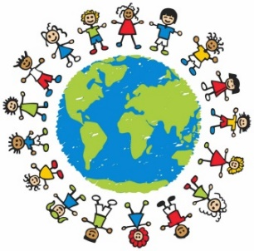  Autumn 1 | Weather  Experts  Autumn 2 | Computing  We will be using computers to complete simple programs and to enhance our learning in other subject areas that might require us to find and sort information. We will also learn about the features of E-safety. | PE  We will be moving to music in Dance and performing the basic movements in gymnastics. Our dance lessons will relate to our Toys’ topic in History.
History  We will be looking at Toys today and in the past and will begin to learn about the lives of significant individuals who have contributed to national and international achievements. | Geography  We will be naming, locating and identifying characteristics of the four countries and capital cities of the United Kingdom and surrounding seas and learning to identify seasonal and daily weather patterns in the United Kingdom.
Art/DT
In Art we will be painting, drawing and modelling in the context of the current themes. In DT we will be making our own toys to use and play with and we will also be creating Christmas crafts.

