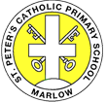
St Peter’s Catholic Primary School
Reception Topics for the Year
Autumn 1 | Autumn 2 | Spring 1 | Spring 2 | Summer 1 | Summer 2
Ourselves | Celebrations | People Who Help Us | Spring | Under the Sea | Topic chosen by the children

